SQL Change Guard
Database Operations Governance Platform
────────────────────────
Govern Every Database Change. Protect Every Production Data Access.
One-Pager | SQL Server | PostgreSQL | Oracle

The Problem We Solve
In most organizations database operations still live in three separate, mostly manual places: change deployment, production data requests, and audit. The result is unanswered questions: who approved it, who ran it, which data left production, was it masked, how do we prove it in an audit.
SQL Change Guard unifies these three areas into one policy-based, end to end auditable platform.
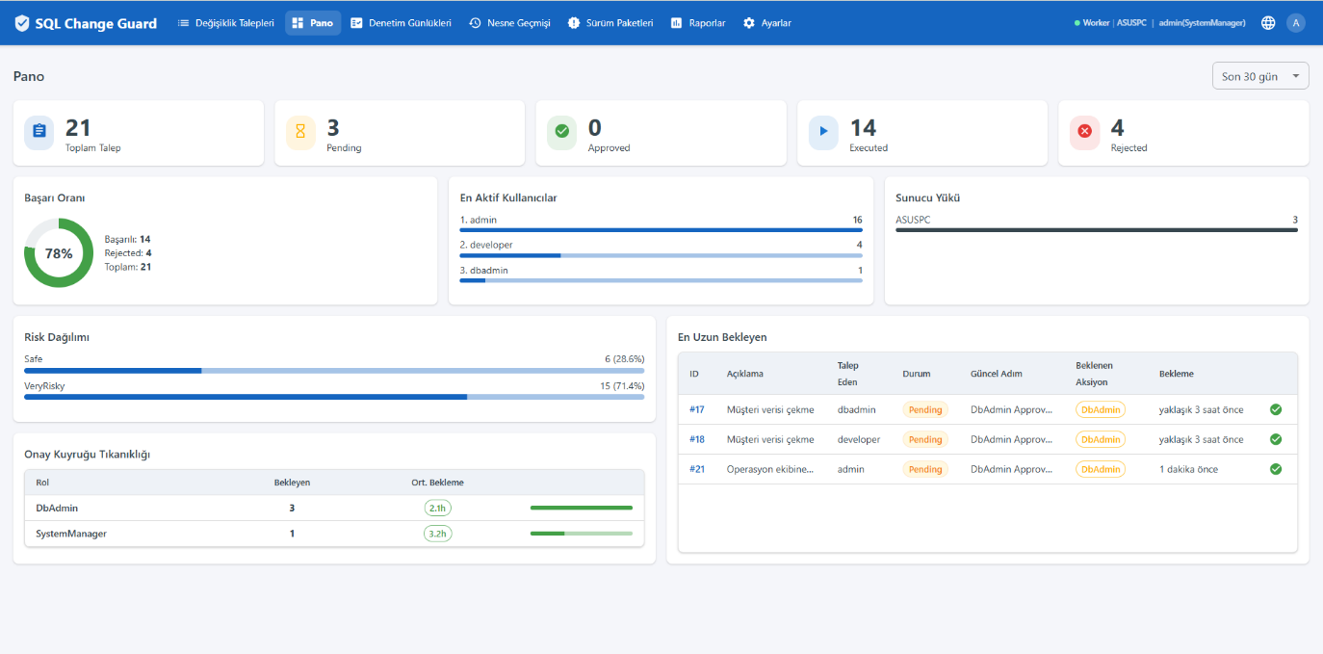
Dashboard - pending approvals, risk distribution and system status
Three Governance Layers
GOVERN - Database Change Governance
▪ Change request with role-based, multi-step approval workflow
▪ Pre-deployment validation with 84+ rules and a 0-100 risk score
▪ Sandbox validation (run and roll back)
▪ Release packages, automated rollback (Oracle atomicity), version and object history

PROTECT - Production Query Governance
▪ Central, policy-based governance of production query requests
▪ Critical object detection and automatic masking for sensitive data (national ID, card, IBAN, phone)
▪ Additional security approval for unmasked data, first-time email verification
▪ Encrypted ZIP delivery, download reason and download tracking

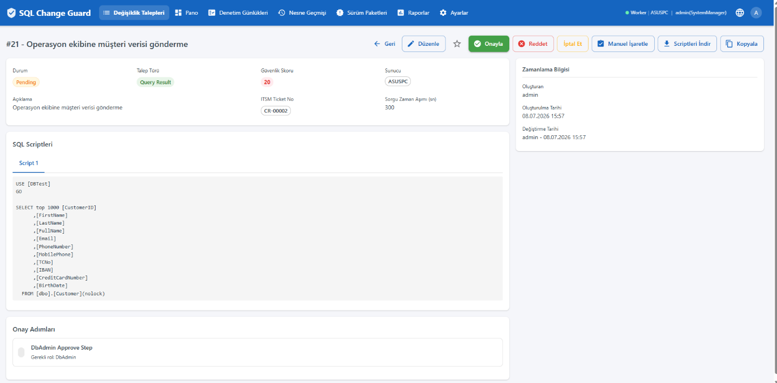
Query Result with automatic masking - sensitive columns (national ID, IBAN, card) are masked
COMPLY - Compliance and Audit
▪ Immutable audit records protected by a hash chain
▪ Approval, download and execution history; evidence packages for audits
▪ 30 built-in reports (DML/DDL/DCL audit, critical object access, privilege movements, QR masking)
▪ Alignment with KVKK, ISO 27001, COBIT and ITIL

Why SQL Change Guard?
Value | What It Delivers
One platform | Change, data access and compliance in one place
Three databases | SQL Server, PostgreSQL, Oracle with the same governance model
Differentiation | Production data access and masking layer, beyond migration tools
On-premise | No data leaves the corporate network, no internet required
Audit ready | Banking and enterprise audit evidence generated automatically

Security is not only about what goes to production; it is also about which data comes out of production.
Contact
▪ Web: www.sqlchangeguard.com
▪ Email: onur.egilmez@sqlchangeguard.com | info@sqlchangeguard.com
▪ Phone: +90 505 621 29 02
▪ LinkedIn: linkedin.com/company/sqlchangeguard

