SQL Change Guard
System Architecture and Topology
────────────────────────
Components, Data Flow and Deployment
On-premise | SQL Server | PostgreSQL | Oracle

1. Component Architecture
SQL Change Guard consists of three main runtime components; all run inside the corporate network.
▪ Web Interface (React): presentation layer where users manage change and query requests
▪ REST API (.NET 10): the core holding business rules, authorization, parsing, risk scoring, policy engine and audit engine
▪ Worker (Windows Service, Quartz): scheduled deployment, auto-execution and release package processing

Business logic lives only on the backend. UI control alone is not accepted as security; all rules are re-validated on the API.
2. Data Layers
▪ Application database (SQL Server): requests, scripts, approvals, roles, parameters, policy definitions, reports
▪ Immutable audit database: tamper-evident audit events protected by a hash chain
▪ Target databases (SQL Server / PostgreSQL / Oracle): live systems where changes are applied and queries run

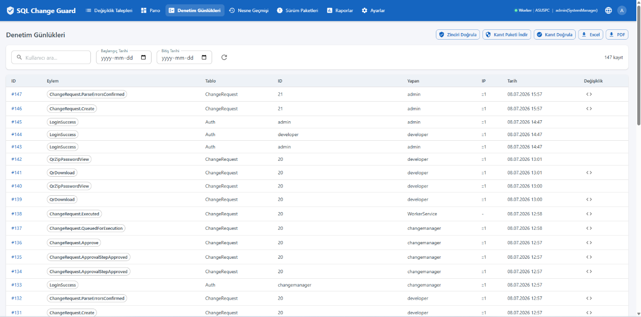
Audit Logs - immutable audit records
3. Logical Flow (Change)
▪ 1. User creates a change request (script) from the web interface
▪ 2. API parses the script, validates with 84+ rules and produces a 0-100 risk score
▪ 3. Policy engine determines approval steps by server/environment/type
▪ 4. Authorized approvers approve by role
▪ 5. Optional: pre-validate with run and roll back in the sandbox
▪ 6. Worker or user executes the approved change on the target database in a single transaction
▪ 7. Result and all steps are written to the immutable audit

4. Logical Flow (Production Query)
▪ 1. User creates a production query (SELECT) request
▪ 2. Policy engine decides approval and masking based on critical table/sensitive column
▪ 3. Required approvals are obtained (DB Admin, security, extra approval for unmasked data)
▪ 4. The query runs; sensitive columns are masked
▪ 5. The result is delivered as an encrypted ZIP; download reason and record are kept
▪ 6. The whole process is written to the audit and QR masking log

5. Network Topology
All components sit within the corporate network; no internet connection is required.
▪ Clients to Web/API (HTTPS)
▪ API to application SQL Server (management data)
▪ API to immutable audit database (audit)
▪ API / Worker to target databases (SQL Server, PostgreSQL, Oracle)
▪ API to LDAP/AD (identity) and SMTP (notification)

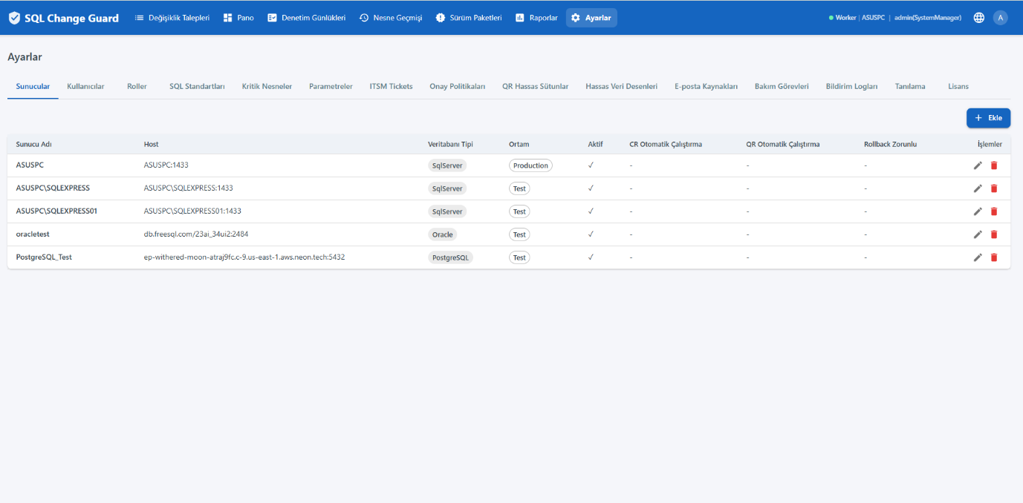
Server Management - multiple SQL Server / PostgreSQL / Oracle in one place
6. High Availability and Recovery
▪ Single-transaction executor: all steps of a request under one transaction; rolled back on failure (SS/PG)
▪ Oracle atomicity: because DDL implicit-commits, Oracle changes containing implicit-commit statements require a rollback, which can be prepared automatically
▪ Immutable audit: records are integrity-protected by a hash chain
▪ Application and immutable databases can be protected with standard backup/replication

7. Contact
▪ Web: www.sqlchangeguard.com
▪ Email: onur.egilmez@sqlchangeguard.com | info@sqlchangeguard.com
▪ Phone: +90 505 621 29 02
▪ LinkedIn: linkedin.com/company/sqlchangeguard

